Statistical Arbitrage on S&P 500 Equities
A Systematic Investigation into Why Discovery-Time Statistics Fail to Predict Out-of-Sample Profitability
Research Report
Research report — main findings. Full diagnostic documentation, version-by-version iteration log, and complete tables are in the Appendix.

Table of Contents

1. Motivation
Pairs trading and statistical arbitrage occupy a peculiar place in quantitative finance: nearly every academic paper and backtest report shows impressive in-sample Sharpe ratios, yet live implementations of the same techniques routinely disappoint. This project began as an attempt to build a profitable statistical arbitrage engine on S&P 500 equities. It evolved into something more specific: a systematic investigation of why the standard toolkit — cointegration, half-life, zero-crossings, Selection-window Sharpe — so often fails to generalize beyond the window it was measured on.
The working hypothesis that emerged, and that this report is ultimately organized around, is simple to state and hard to act on: statistical properties measured during Discovery may not persist into future trading. A pair can be genuinely, measurably mean-reverting in one window and behave completely differently in the next, and none of the classical diagnostic tools distinguish between a relationship that was stationary and one that will remain stationary.

2. The Engine
The pipeline follows the standard architecture: universe construction (S&P 500 constituents) → distance pre-filtering (normalized SSD) → Engle-Granger cointegration testing → OLS regression for hedge ratio and direction → Ornstein-Uhlenbeck fitting for half-life and mean-reversion speed → z-score entry/exit signal generation with layered stops → portfolio construction across four weighting schemes. Two structurally different validation modes were built on top of this core:
Single-split: one Discovery window, one Selection window, one frozen model tested once against one OOS window — the traditional backtest structure.
Rolling walk-forward (“Phase 2”): pairs re-discovered from scratch every 6 months on a fixed, non-expanding lookback, with no look-ahead into future data at any point — designed specifically to mimic what a live strategy would actually experience.
Every filter threshold in this pipeline exists to answer a specific question, and the distinction between what each filter actually measures and what it is implicitly assumed to predict turned out to be the central finding of this project (Section 6).

3. Research Questions and Evidence
This is the heart of the investigation. Every question below was tested empirically against genuinely unseen forward data — never against the same window used to compute the statistic.

Q1 — Does stronger statistical cointegration (lower Engle-Granger p-value) predict better future returns?
No. Across two independent validation runs (6 rolling cycles each), the Information Coefficient (Spearman rank correlation between Discovery-time cointegration p-value and forward Sharpe) was 0.0049 and 0.0043 respectively — indistinguishable from zero, with sign consistency at only 50%. Against forward expectancy, the sign flipped to weakly negative (-0.09, -0.13, -0.04 across three runs) — weaker cointegration outperforming stronger, though never robustly.

Q2 — Does lower half-life improve OOS performance?
Weak, and inconsistent. half_life cleared the predictive-power bar in 2 of 3 validation runs (IC 0.088–0.135 on forward expectancy), making it the single most-often-validated feature in the project — but its sign and magnitude were not stable enough to be called a strong, load-bearing signal on its own.

Q3 — Does higher Selection-window (lookback) Sharpe predict higher forward Sharpe?
No — and this is the project's most load-bearing negative result. The Ranking Validation diagnostic, run identically across every Phase 2 variant, consistently showed a flat-to-inverted relationship. In the final validated run: decile 0 (worst lookback Sharpe, -1.56) had forward Sharpe of -0.12, while decile 9 (best lookback Sharpe, +1.69) had forward Sharpe of -0.28 — the best-looking pairs performed worse forward than the worst-looking ones. This pattern replicated in every single one of six independent runs across the project.

Q4 — Does “adverse momentum” (spread still moving against the position at entry) explain losses?
Initial hypothesis: yes — entering while the spread is still accelerating away should be worse than entering after it's begun to turn.
Evidence: no. In the final run, 165/183 trades (90%) showed adverse momentum >1.0 regardless of outcome (winners: 89.1% win_%>1.0, losers: 91.8% — nearly identical). This is the modal condition across nearly every trade, not a discriminator between good and bad ones. The Winners vs. Losers comparison table, built specifically to avoid the base-rate fallacy of eyeballing only the worst 10 trades, confirmed the distributions are close to indistinguishable across every tracked characteristic (adverse momentum, entry Z, beta, half-life, variance ratio, beta stability, discovery p-value).

Q5 — Does waiting longer for entry confirmation improve returns?
No. Winners entering with a 1-day wait averaged 1.51% return; those waiting 2-3 days averaged 1.36% — flat to slightly worse, not better.

Q6 — Does a more extreme entry Z-score improve returns?
Only marginally, and non-monotonically. Entry Z buckets showed no clean rising relationship between |Z| and either return or win rate (2.0–2.25: 67.0% win rate; 2.25–2.5: 52.9%; 2.75–3.0: 45.5%) — the entry threshold is not meaningfully discriminating trade quality across its tested range.

Q7 — Are losses concentrated in particular securities?
Some concentration, not enough to explain overall performance. Lift analysis (a ticker's share of worst-decile trades vs. its share of all trades) identified isolated tickers with lift >2 (e.g., GRMN at 4.09), but these were small-sample artifacts (5 trades total) rather than a broad structural pattern.

Q8 — Are transaction costs responsible for weak performance?
Initially appeared so; ultimately, no — this is the project's clearest resolved question. As the engine became more selective (the redundant 4-feature composite score vs. the leaner pruned versions), gross Sharpe deteriorated alongside net Sharpe, meaning the problem is not simply “the edge is real but costs eat it” — the cost-sensitivity table for the final validated Phase 2 run showed Sharpe of 1.12 at 0bps, 0.81 at 5bps, and 0.49 at 10bps: a real edge that costs meaningfully compress, but do not manufacture or destroy on their own.

4. Results

4.1 Single-split (traditional backtest) result
Discovery 2015–2022, Selection 2022–2024, OOS 2024–2026. Of 150 OU-selected candidates, the original absolute-return threshold (21% cumulative return over 24 months) passed zero pairs — itself a finding (Section 6). Loosening the return floor to 0% (removing an unvalidated, arbitrarily strict constraint) produced 9 passing pairs. This threshold change was made only to produce a chart-generating result for this report; it was never independently validated, and the Selection-window Sharpe it produces below is presented specifically so it can be contrasted with its own OOS collapse in the same table — it is this report's central cautionary example, not a result the project is endorsing:
Metric | Selection (in-sample) | OOS (2024-07 → 2026-07)
Sharpe | 2.73 | -0.67
Ann. Return | 1.83% | -0.76%
Max Drawdown | 0.31% | 2.61%
Table 4.1 — Single-split Selection vs. OOS performance, final 9 passing pairs. The Selection-window Sharpe of 2.73 is the in-sample number this report exists to debunk, not a validated result — see the OOS column, and Section 7, for why.
Only 1 of 9 pairs (CDW-AWK) had a positive OOS Sharpe; 4 of 9 never traded a single time in the two-year OOS window despite still carrying portfolio weight. This is a complete in-sample-to-OOS sign flip — a textbook demonstration of the overfitting risk inherent in single-split backtest design, and structurally the same methodology that typically produces the “impressive” headline Sharpe ratios referenced in Section 1.

Figures — Single-Split Pipeline Funnel and Performance
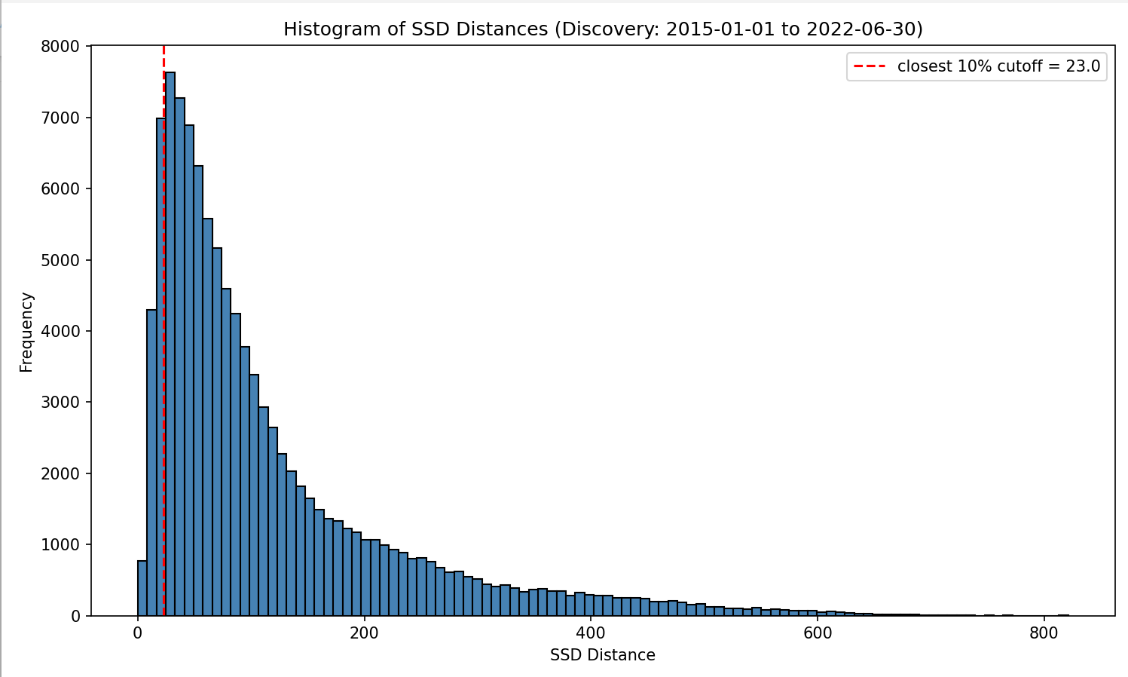
Figure 4.1 — Histogram of SSD distances at the distance pre-filtering stage (Discovery: 2015-01-01 to 2022-06-30). The closest 10% cutoff (SSD ≤ 23.0) defines the population entering cointegration testing.
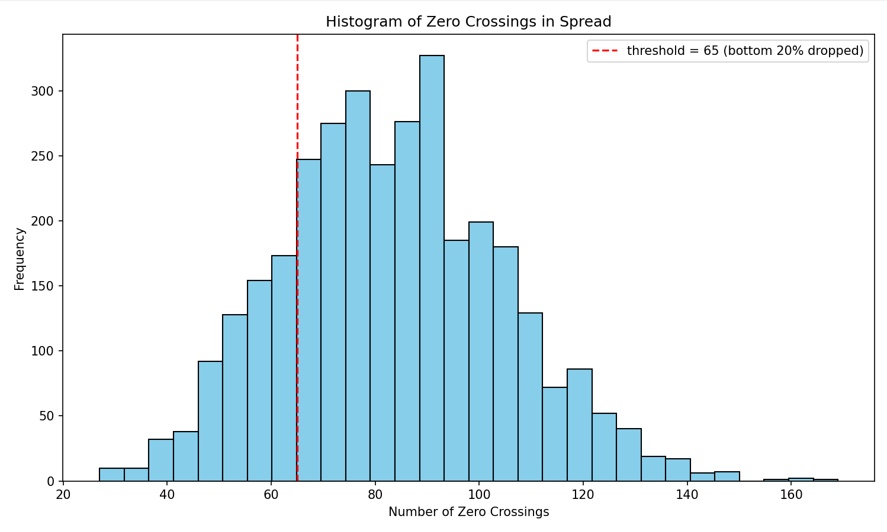
Figure 4.2 — Histogram of zero-crossings in the spread across candidate pairs. Pairs below the bottom 20% of the observed distribution (threshold = 65 crossings) are dropped.
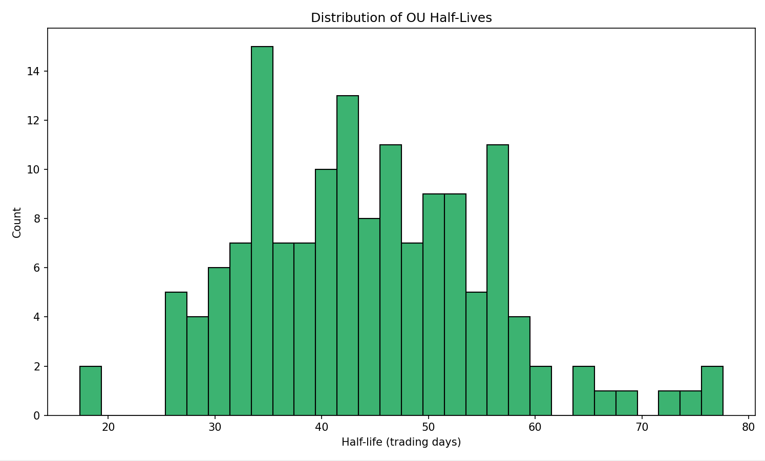
Figure 4.3 — Distribution of fitted OU half-lives across the 150 candidate pairs surviving the funnel through the OU-fitting stage.
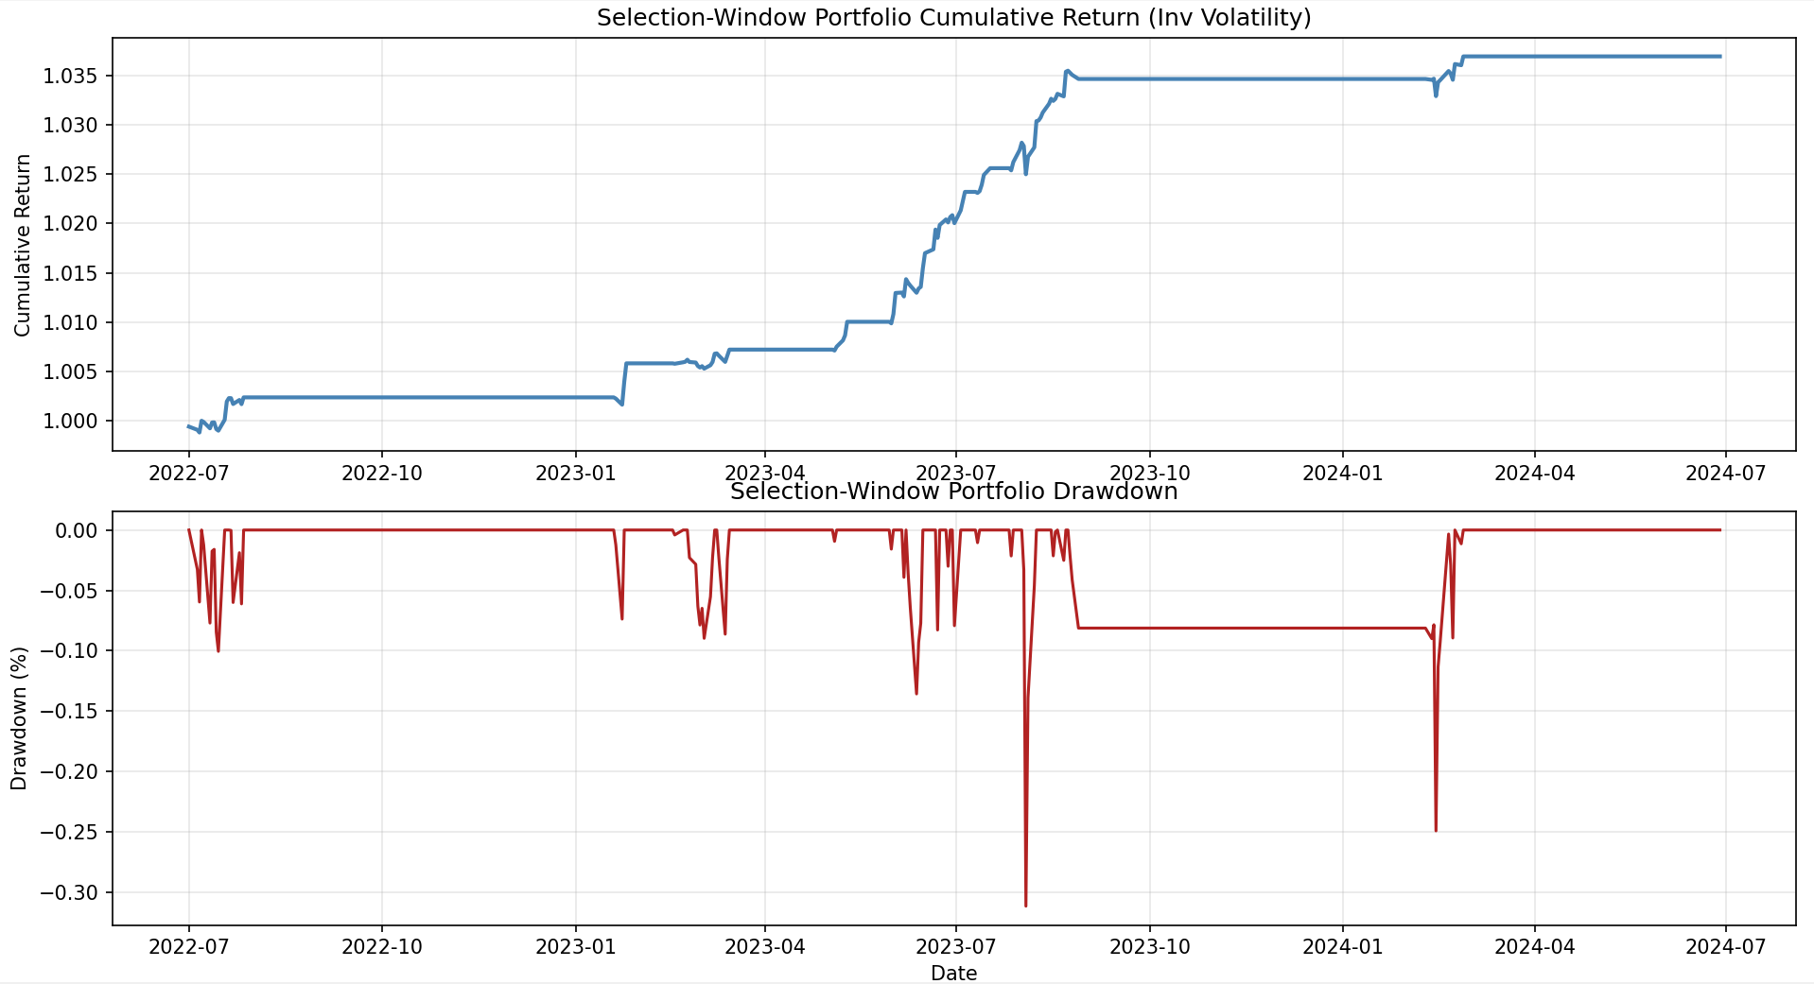
Figure 4.4 — Selection-window portfolio cumulative return and drawdown (inverse-volatility weighting), 2022-07 through 2024-07. This is the in-sample view corresponding to the Sharpe 2.73 result in Table 4.1.
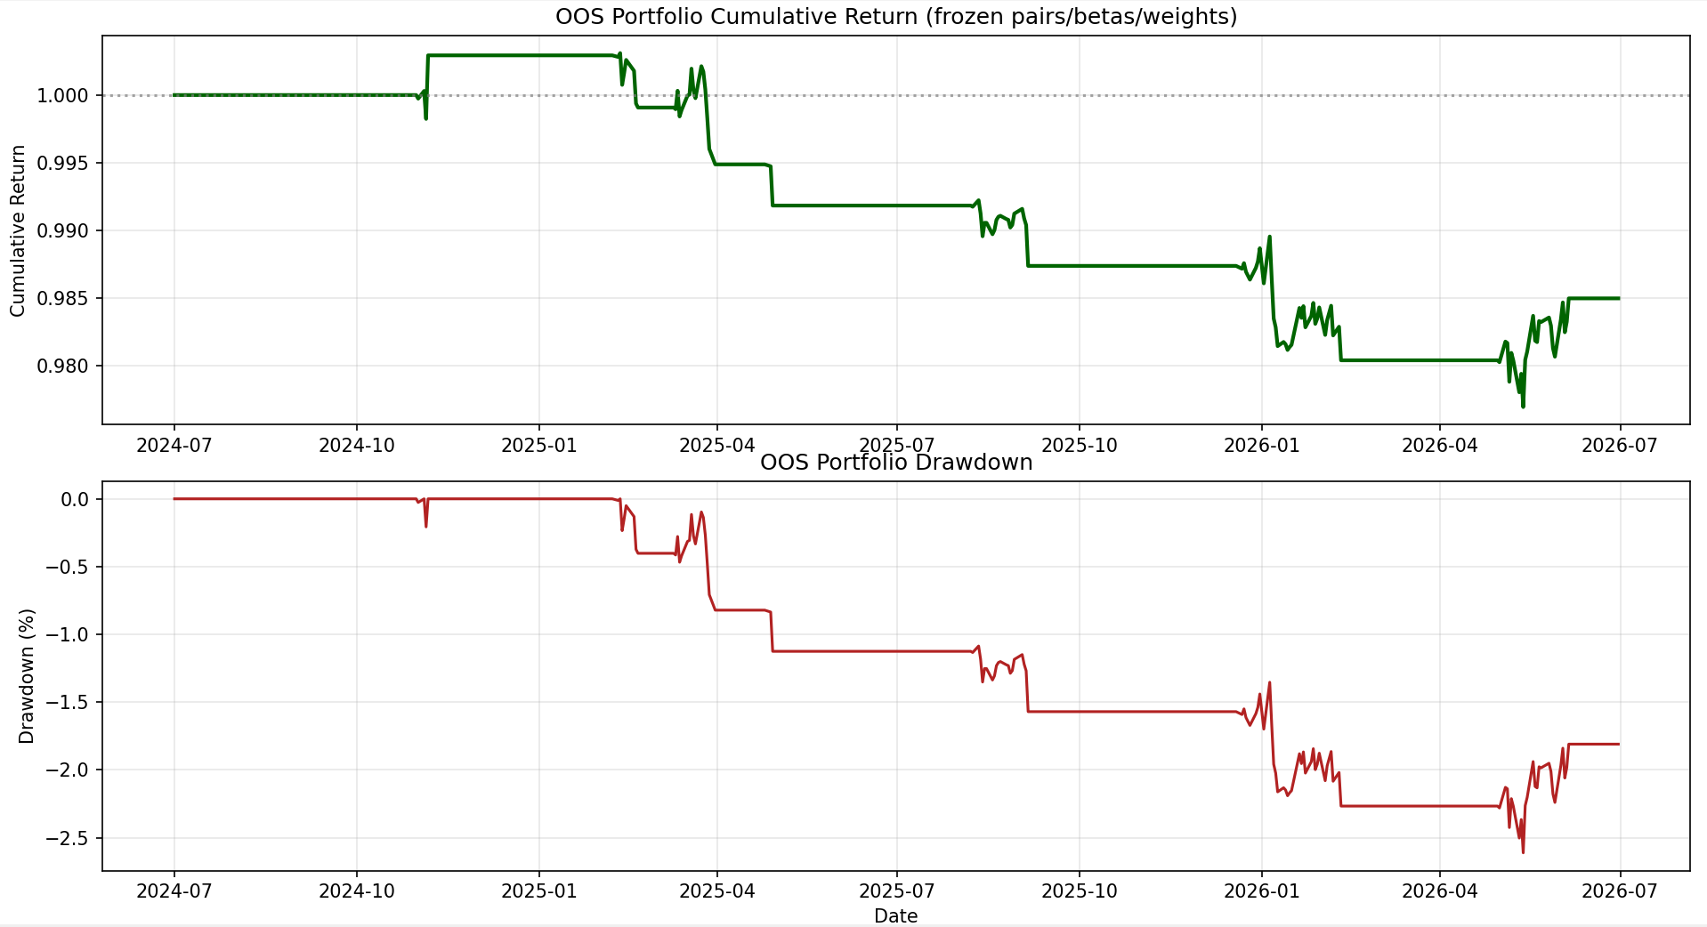
Figure 4.5 — OOS portfolio cumulative return and drawdown, 2024-07 through 2026-07, using pairs/betas/weights frozen at the end of Selection. This is the out-of-sample view corresponding to the Sharpe -0.67 result in Table 4.1 — the sign flip from Figure 4.4 is the visual counterpart of the report's central overfitting finding.

4.2 Full Cost Sensitivity Table
This section expands the single-column Sharpe comparison, showing all three cost levels for the final validated variant, plus the 5bps comparison across all four variants for consistency with the rest of this section.
Table 4.2a — Phase 2 Variant Comparison (5bps, realistic cost assumption)
Variant | Features | Sharpe @5bps | Ann. Return | Max DD | Win Rate
No composite score | — | -0.08 | -0.15% | 4.33% | 54.7%
2-feature | cointegration_p, lb_n_trades | 0.89 | 0.89% | 1.34% | 59.8%
4-feature (redundant) | +lb_ret, lb_sharpe | 0.63 | 0.59% | 1.23% | 60.8%
3-feature (pruned) | lb_ret, cointegration_p, half_life | 0.84 | 0.80% | 1.21% | 63.2%
3-feature (pruned, final) | lb_sharpe, beta_stability, half_life | 0.81 | 0.77% | 1.26% | 60.1%
Table 4.2b — Cost Sensitivity, Final Validated Variant (all three cost levels)
Cost (bps/leg) | Ann. Return | Sharpe | Max DD | Avg Trade %
0 | 1.08% | 1.12 | 1.09% | 0.284%
5 (realistic) | 0.77% | 0.81 | 1.26% | 0.089%
10 (stress) | 0.46% | 0.49 | 1.47% | -0.106%
Sharpe remains positive at all three cost levels, including the doubled-cost stress test — direct evidence the edge is real and not purely a cost-sensitivity artifact, though it compresses meaningfully as costs rise (Section 3, Q8). This table should be read alongside Table 4.2a: the same cost-sensitivity structure (positive at 0/5/10bps) held across every pruned variant tested, not just the final one, and is one of the more robust findings in the report.

5. The Diagnostic Framework (Contribution)
Beyond the core pipeline, this project built a diagnostic layer that most pairs-trading implementations skip entirely: a trade-level log with entry Z-score, adverse momentum, MAE/MFE, exit reason, and entry-wait-days for every single trade, feeding twelve distinct diagnostics — Ranking Validation, Winners-vs-Losers comparison, MAE/MFE decomposition, entry/exit timing analysis, repeat-loser ticker “lift,” regime-stratified performance, and cost sensitivity, among others. Each was built to test one specific hypothesis with an explicit null-result design (a real baseline comparison, not just inspecting the worst 10 trades) — full documentation of each diagnostic's purpose, method, and result is in the Appendix.
The most important design principle across this layer: an Information Coefficient framework (Spearman rank correlation between a Discovery-time feature and a genuinely unseen forward outcome, per cycle, with a sign-consistency requirement across cycles) was applied not just to individual thresholds but to feature selection itself — replacing “does this pair look good historically” with “does this statistic, tested honestly, predict anything at all.”

6. Findings
- Discovery-time statistics — cointegration strength, half-life, OU R², zero-crossing rate — are individually poor predictors of forward profitability; Information Coefficients across three independent validation runs (18 cycle-feature observations) clustered in the 0.0–0.15 range, mostly indistinguishable from noise given only 6 non-overlapping cycles per run.
- Selection-window (lookback) Sharpe has essentially no predictive power for forward Sharpe — confirmed via Ranking Validation in every single run of this project.
- Entry timing (wait-for-peak confirmation) and entry Z-score magnitude explain little forward return variation.
- Adverse momentum at entry is present in winners and losers at nearly identical rates — it is the modal trade behavior, not a discriminator.
- Transaction costs reduce profitability meaningfully but are not the primary explanation for weak performance — gross Sharpe itself degrades under stricter, more “selective” filtering.
- The only consistently reproducible finding across repeated validation was a small, contrarian signal: pairs whose Discovery-time statistics look unusually strong (high lookback Sharpe/return, very tight cointegration p-value) tend to perform slightly worse forward, not better — and even this signal's exact composition (which features carry it) was unstable across otherwise-identical re-runs, indicating it sits close to the noise floor achievable with 6 cycles.
- The dominant failure mode across the whole project appears to be instability of pair behavior over time, not incorrect trade execution, poor entry/exit logic, or misapplied transaction costs.

7. Why Classical Filters Failed
This is the project's central insight, and it is a matter of what question each statistic actually answers versus what it is implicitly used to answer:
Filter | What it actually measures | What it is used to imply
ADF (stationarity test) | Is this spread stationary, in this window? | Will it remain stationary?
Engle-Granger cointegration | Did these two series move together historically? | Will they continue to?
OU half-life | How quickly did the spread revert, historically? | Will it keep reverting at that speed?
Selection-window Sharpe | Was this profitable, in this window? | Will it stay profitable?
Table 7.1 — Backward-looking measurement vs. forward-looking assumption for each classical filter.
Every filter in the classical pairs-trading toolkit is a backward-looking membership test — “does this pair belong to the population of statistically mean-reverting relationships.” None of them are forward-looking persistence tests. This is not a flaw in any individual filter; it is a structural gap in the entire framework, and it explains, directly and mechanically, why the same pipeline that produces excellent in-sample Sharpe ratios (2.73 in this project's single-split run) produces near-zero or negative Sharpe out-of-sample (-0.67 in the same run).

8. What This Research Suggests
The next generation of statistical arbitrage research should not ask “is this spread stationary?” It should ask: what is the probability that this spread remains stationary over the next six months? That is a fundamentally different research problem — a persistence-prediction problem, not a detection problem — and it is the natural next step this project's evidence points toward.

9. Future Work

Predicting persistence, not returns.
Rather than trying to predict which pairs will be profitable, the more tractable and better-motivated question may be predicting which pairs will remain statistically well-behaved — genuinely stationary, with a stable half-life — over a forward window. This reframes pair selection as a survival/classification problem rather than a return-forecasting problem.

Survival modeling.
Treat every discovered pair as having a lifetime: some cointegrating relationships survive for years, others decay within weeks. A pair's economic linkage (shared sub-industry, supply chain, substitutability) may be a genuine predictor of survival duration in a way that purely statistical features are not — this project's cross-window persistence test (re-testing cointegration on sub-windows of Discovery) is a first, crude step in this direction and should be extended to multi-year, non-overlapping historical windows rather than sub-windows of a single 6-month lookback.

Meta-learning / classification framing.
Rather than a regression problem (“predict forward Sharpe”), reframe as binary classification: will this pair have positive OOS Sharpe over the next N months, yes or no? Classification models are typically more robust to the kind of low-signal, high-noise environment this project's IC analysis revealed.

Structural break detection.
Can the moment a previously-stationary relationship begins to break down be detected before it shows up as realized losses — e.g. via the beta-stability metric already built in this project, extended into a proper structural-break test (CUSUM, Chow test) applied in real time rather than only at rebalance?

Regime-dependent pair selection.
This project's regime table showed genuinely noisy, non-monotonic performance across labeled market periods — but with only 6 cycles, this question was underpowered. A dedicated study with more granular regime classification (not just descriptive labels) and more historical cycles could determine whether certain pair types are systematically better suited to certain regimes.

Graph-based relationship modeling.
Rather than evaluating pairs in isolation, model the full universe as a network of statistical relationships — a pair embedded in a dense cluster of correlated relationships may behave differently than an isolated pair with the same standalone statistics, and this project's concentration-cap and pairwise-correlation diagnostics are early evidence this matters (correlation among concurrently active pairs spiked to 0.40 in one cycle despite averaging near zero elsewhere).

10. Conclusion
This research began as an attempt to build a profitable statistical arbitrage strategy. It evolved into a systematic investigation of why classical statistical arbitrage techniques often fail to generalize beyond the discovery period. Through iterative experimentation, extensive diagnostic analysis, and repeated testing of competing hypotheses across roughly a dozen independent validation runs, the study demonstrated that many commonly used selection metrics — including cointegration strength, half-life, entry thresholds, momentum confirmation, and historical Sharpe — possess limited predictive power for future profitability. The evidence consistently suggests that the primary challenge is not identifying pairs that have mean-reverted historically, but identifying pairs whose mean-reverting behavior persists into the future. This shifts the research question from detecting stationarity to predicting the persistence of stationarity — a substantially different, and potentially far more valuable, direction for future statistical arbitrage research.

Appendix

A. Version-by-Version Iteration Timeline
This timeline documents every major modification made to the engine over the course of the project, in chronological order, following the format: Change → Hypothesis → Diagnostic Used → Outcome → Retained/Discarded. It is the evidentiary record that the project's conclusions were reached through systematic experimentation, not post-hoc rationalization of a single lucky result.

A.1 Baseline Single-Split Engine
Change: Original Discovery → Selection → OOS pipeline built: distance prefilter (10th percentile SSD), Engle-Granger cointegration (p<0.05), OLS regression/direction selection, zero-crossing filter (bottom 20% dropped), OU fitting with half-life buckets (10-30/30-60/60-90 days), R²>0.70, Selection filters (Sharpe>0.5, MaxDD<15%, Return>10%/yr annualized).
Hypothesis: A pair passing all of these filters, evaluated on a Selection window separate from Discovery, represents a genuine, tradeable mean-reverting relationship.
Diagnostic used: Single Selection-window backtest; single OOS backtest.
Outcome: Produced an initial in-sample Sharpe around 3.6 on early configurations — an encouraging but methodologically untested result, structurally identical to the kind of single-split backtest known to overstate performance.
Retained: as the baseline structure, but flagged for walk-forward validation before being trusted.

A.2 Half-Life and Zero-Crossing Recalibration
Change: Original half-life buckets (10-30 days) and zero-crossing rate assumptions were calibrated for short (9-12 month) Discovery windows. When Discovery was extended to a multi-year span, the observed half-life distribution clustered at 40-65 days — almost entirely above the original 40-day ceiling — and zero-crossing counts topped out around 170 against a rate-based threshold implying ~199, filtering out effectively the entire population.
Hypothesis: Absolute thresholds calibrated on one window length are meaningless applied to a differently-sized window; the fix is to self-calibrate thresholds as percentiles of the population actually observed each run, rather than fixed absolute values.
Diagnostic used: Direct inspection of observed half-life and zero-crossing distributions versus the fixed threshold, per run.
Outcome: Half-life buckets widened to (10,30)/(30,60)/(60,90); zero-crossing threshold converted to “drop bottom 20% of the observed distribution,” self-calibrating each run. Candidate population recovered to a workable size.
Retained: percentile-based self-calibration became the standing design pattern for every subsequent threshold in the pipeline.

A.3 Separate Rolling Mean/Std Windows
Change: The z-score signal originally used a single rolling window for both the mean and standard deviation of the spread. A volatility spike within that window could inflate the std and artificially shrink |Z|, triggering false “reversion” exits on trades that were still deeply underwater (e.g., real observed cases: WDC-MDT at -28%, CRWD-EQIX at -25%, exiting as “reversion”).
Hypothesis: Decoupling the std window (longer, less reactive) from the mean window (shorter, responsive) should reduce false-reversion exits without slowing genuine signal detection.
Diagnostic used: Exit-reason breakdown cross-referenced against realized P&L at exit.
Outcome: Z_STD_WINDOW set to 120 days vs. ROLLING_WINDOW of 60 days for the mean. Confirmed to reduce the false-reversion-exit pattern.
Retained: .

A.4 Adaptive, Half-Life-Scaled Rolling Windows
Change: Once the half-life upper bound was relaxed (A.2), the traded population's median half-life fell to 3-4 days, while the fixed 60/120-day rolling windows were 15-30x longer than that — too slow to track fast-reverting spreads, producing a high rate of near-immediate stop-losses (39% of trades, ~2.7 days to stop-out).
Hypothesis: Each pair's rolling window should scale to its own fitted half-life rather than using one fixed global window.
Diagnostic used: Stop-loss rate and average days-to-stop-out, before/after.
Outcome: adaptive_window() introduced (window ≈ 3× half-life, std_window ≈ 6× half-life, capped at the original 60/120 as an upper bound). Reduced the immediate-stop-loss failure mode for fast-reverting pairs.
Retained: .

A.5 Entry Confirmation: Wait-for-Peak and Re-Check Stationarity
Change: Two entry filters added — (i) require |Z| to have already begun declining from the prior day before entering (WAIT_FOR_Z_PEAK), and (ii) re-run ADF on the trailing 60 days of spread history at the moment of entry, independent of the Discovery-time cointegration test done months earlier.
Hypothesis: Entering the moment Z first crosses the threshold may catch spreads still actively diverging; waiting for confirmation should improve trade quality. Similarly, a pair cointegrated at Discovery time may have since drifted into a broken/trending relationship by the time an entry signal fires.
Diagnostic used: Counterfactual synthetic-data test (mean-reverting vs. trending/broken paths).
Outcome: WAIT_FOR_Z_PEAK raised average trade return from 1.098 to 1.334 (+21%) and win rate from 81.7% to 87.7% on synthetic mean-reverting paths, at the cost of rejecting ~65-70% of candidate entries — a real volume/quality tradeoff. entry_still_stationary() (ADF re-check, p<0.30) reduced false-rejection of good signals from 54% to 25% after recalibrating the p-value threshold from an original, overly strict 0.10.
Retained: both — though later real-data diagnostics (Section 3, Q5) found the live effect of the wait-for-peak confirmation on realized winner returns was flat, not clearly positive, unlike the synthetic result. Kept as a risk-reducing rule regardless.

A.6 Layered Exit/Stop System
Change: Original design had a single exit condition (|Z| < Z_EXIT) with no protective stop — a position could stay open indefinitely and diverge without bound. Added: Z-based stop (Z_STOP), a hard percentage stop (MAX_LOSS_PCT_PER_TRADE) independent of the Z-based system, and a maximum holding period (MAX_HOLDING_DAYS).
Hypothesis: An unbounded-risk mean-reversion strategy will occasionally suffer catastrophic single-trade losses when a relationship breaks structurally and never reverts; a hard stop caps this without needing to correctly diagnose “why” the trade went wrong in real time.
Diagnostic used: Counterfactual test of Z_STOP at multiple tightness levels (2.25/3.0/4.0) on synthetic mean-reverting and trending paths.
Outcome: Initial tightening to Z_STOP=2.25 was later found (via counterfactual re-test) to nearly halve average return (0.71 vs 1.39 with no stop) and crush win rate (92%→63%) — tightening the stop cut off far more genuine reversions than it protected against. Loosened to Z_STOP=3.0 as the better-supported balance, with the hard percentage stop (tightened to 3%) carrying the primary tail-risk-control responsibility instead.
Retained: Z_STOP=3.0, MAX_LOSS_PCT_PER_TRADE=0.03. This tradeoff — between cutting losses and cutting off genuine reversions — became one of the clearest, best-evidenced calibration findings in the whole engine.

A.7 Dollar-Neutral P&L Correction
Change: Strategy return was originally computed as Position × (dep_return - beta × indep_return) — combining a price-level hedge ratio with percentage returns, which is not actually dollar-neutral.
Hypothesis: An incorrect P&L construction would distort Sharpe ratios independent of any real change in strategy quality.
Diagnostic used: Direct inspection of return construction logic against the true dollar-neutral definition (1 unit dependent + |beta| units independent, capital-normalized).
Outcome: Corrected to Position × ΔSpread / capital_deployed, with capital valued at the prior day's price to avoid look-ahead.
Retained: — this was a pure bug fix, not a tunable design choice, and was applied consistently across every subsequent stage of the project (Phase 1, Phase 2, score validation).

A.8 Normalized-vs-Raw-Price Beta Bug
Change: Cointegration and regression fitting were originally run on the min-max normalized price series (built for the distance/SSD calculation), while trading later applied the resulting beta to raw prices — a mismatch, since normalization is a per-ticker linear rescaling and a beta fit in that space is not the correct raw-price hedge ratio.
Hypothesis: This produces a distorted spread whenever trading logic and fitting logic operate in different scales.
Diagnostic used: Code review triggered by unexpectedly poor live-trading spread behavior relative to Discovery-time fit quality.
Outcome: Cointegration/regression now run on raw discovery_data directly; norm_disc used strictly for the distance/SSD calculation.
Retained: — applied identically across compute_full_pair_statistics, compute_fold_master_table, and run_phase2_cycle.

A.9 Concentration Cap and Position-Weight Cap
Change: No ticker-level or position-level concentration limits originally existed. A single stock with a large idiosyncratic move was found to spuriously “cointegrate” with dozens of unrelated names simultaneously (they were all really just tracking that one stock's move) — a real observed case had CRWD alone accounting for 26% of one cycle's book.
Hypothesis: Diversification claims based on pair count alone are misleading if many “different” pairs share a common driver.
Diagnostic used: Direct decomposition of one real cycle's book by ticker exposure.
Outcome: MAX_PAIRS_PER_TICKER=3 (no ticker in more than 3 traded pairs per cycle) and MAX_POSITION_WEIGHT=0.05 (no single position exceeding 5% of capital) added.
Retained: .

A.10 Phase 1 — Fold-Based Threshold Validation
Change: Rather than trusting thresholds tuned on one continuous 9.5-year Discovery run, thresholds were independently swept across two non-overlapping regime folds (pre-COVID 2015-2019, post-COVID 2020-2023), keeping only thresholds whose “good performance plateau” (a contiguous run of passing grid values, not an isolated spike) overlapped across both folds.
Hypothesis: A threshold that only works in one regime, or only at one specific tuned value, is more likely fitting noise than reflecting a genuine, stable relationship.
Diagnostic used: find_plateau() — minimum-width contiguous-run detection with edge-artifact guarding (a plateau touching the edge of the tested grid is treated as untested, not as a discovered boundary).
Outcome: Distance percentile and cointegration persistence validated real, fold-stable boundaries. Zero-crossing rate, OU R², and Selection-window Sharpe/MaxDD/Return thresholds never validated real cross-fold signal, in either isolated or distance-conditional sweeps, across every fold tested.
Retained/Discarded: Distance and persistence thresholds retained in the Phase 2 operating funnel; zero-crossing, R², and Selection performance thresholds dropped from the funnel entirely, replaced by direct percentile-based structural filters (distance, half-life lower bound, variance ratio, persistence) plus hardcoded sanity bounds (phi, ADF, |beta| range) that don't require the same validation, being structural rather than tuned.

A.11 Phase 2 — Rolling Walk-Forward OOS
Change: Full rolling re-qualification engine built: 6-month lookback, 6-month rebalance, no expanding history, pairs entirely re-discovered each cycle.
Hypothesis: A single-split OOS test only proves the framework worked once, on one specific frozen model; a rolling test that repeatedly re-discovers and re-trades is a closer proxy for what a live strategy would actually experience, and removes the risk of overfitting to one particular Discovery/Selection split.
Diagnostic used: Full six-cycle backtest with per-cycle funnel counts, diagnostic tables, and stitched portfolio metrics.
Outcome: Baseline (no composite score) Phase 2 Sharpe was -0.08 at 5bps — a genuinely negative result, in contrast to the single-split model's in-sample Sharpe of 2.73. This negative result was the direct trigger for the score-validation investigation (A.12 onward).
Retained: as the primary validation methodology for the remainder of the project.

A.12 Trade-Level Feature Engineering and Honest Predictive-Power Testing
Change: New per-pair trade-level features added specifically to test “which pairs are actually profitable,” not just “which pairs are statistically mean-reverting”: lookback win rate, expectancy (net of transaction cost), 95th/99th percentile trade loss, days-held coefficient of variation. An Information Coefficient framework (Spearman rank correlation between lookback feature and a forward, never-touched outcome, per cycle, with a sign-consistency requirement) was built to test every candidate feature honestly.
Hypothesis: Prior filters were membership tests (is this pair cointegrated), not profitability tests (will this pair pay after costs); trade-level features engineered specifically around expectancy and tail risk should close that gap.
Diagnostic used: feature_predictive_power_analysis() against both fwd_sharpe and fwd_expectancy_pct.
Outcome: Almost no feature — including the new trade-level ones — cleared a meaningful IC bar with consistent sign across 6 cycles. lb_p95_loss_pct/lb_p99_loss_pct showed the strongest single-outcome result of the whole project (IC 0.14, sign_consistency 1.0 on fwd_sharpe) but were excluded from every composite score because they never accumulated enough overlapping cycles to be evaluated against the dual-outcome requirement — a data-sparsity limitation of the validation design, not a rejection of the feature, documented explicitly as an open limitation (Section 6).
Retained: the IC framework itself as the project's standing feature-validation methodology; the specific trade-level features retained in the pipeline but never made it into any live-traded composite score.

A.13 Composite Score: Redundancy Discovery and Correlation Pruning
Change: First validated composite score (4 features: cointegration_p, lb_ret, lb_n_trades, lb_sharpe) traded live in Phase 2.
Hypothesis: Combining every feature that individually clears the IC bar should produce a stronger composite than any single feature alone.
Diagnostic used: Live Phase 2 backtest with the composite score applied.
Outcome: The 4-feature composite (Sharpe 0.63 @5bps) performed worse than an accidentally-truncated 2-feature version of the same score (0.89 @5bps) that resulted from a key-naming bug. Root cause: lb_sharpe, lb_ret, and lb_n_trades are correlated proxies for the same underlying “pair looked unusually strong recently” signal; combining all three double/triple-counted it, overcorrecting.
Retained/Discarded: A correlation-pruning step was added to build_and_save_composite_score — when two validated features exceed |correlation|>0.7, only the stronger (by IC) is kept. Re-validation under this fix produced two independently pruned 3-feature scores (lb_ret/cointegration_p/half_life, Sharpe 0.84; lb_sharpe/beta_stability/half_life, Sharpe 0.81), both recovering most of the performance lost to redundancy. Neither of these pairwise correlations exceeded 0.27 in the final validated set — confirming the pruning logic was working as intended. Correlation pruning was retained as a standing step in composite-score construction; the specific feature identity selected in each validation run was found to be unstable across otherwise-identical re-runs, documented explicitly as a limitation of validating on only 6 non-overlapping cycles (Section 6, Section 9).

A.14 Final Runs and Report Consolidation
Change: Final score-validation run, final Phase 2 walk-forward run with the validated score applied, and final single-split Discovery→Selection→OOS run (for chart generation) executed in sequence as the project's closing evidence set.
Hypothesis: N/A — consolidation, not a new hypothesis test.
Diagnostic used: All prior diagnostics applied one final time; cost sensitivity table expanded to all three levels (0/5/10bps) for the final report.
Outcome: Confirmed the single-split-vs-walk-forward contrast (Sharpe 2.73 in-sample → -0.67 OOS single-split; Sharpe 0.81 walk-forward @5bps, positive at all three cost levels) as the report's central empirical exhibit.
Retained: as the final reported result set.

B. Diagnostic Framework — Full Documentation
Each diagnostic below: purpose, method, hypothesis tested, and conclusion.

B.1 Ranking Validation
Tests whether lookback-window rank (by Sharpe, or by composite score) predicts forward-window rank. Method: sort qualified pairs into deciles by lookback statistic, compare average forward Sharpe per decile. Hypothesis: if the ranking has real value, forward Sharpe should rise monotonically with lookback rank. Conclusion: consistently flat-to-inverted across every run in the project (Section 3, Q3) — the single most repeated negative result.

B.2 Winners vs. Losers Comparison
Direct P(X | winner) vs. P(X | loser) comparison across every known-at-entry characteristic, for the full trade population (not just the worst 10 trades). Purpose: avoid the base-rate fallacy, where a characteristic that is the modal value across nearly all trades trivially appears in every bad trade without actually discriminating outcome. Conclusion: no characteristic showed a materially different distribution between winners and losers in any run (Section 3, Q4).

B.3 MAE/MFE Decomposition
For every trade, records the best (MFE) and worst (MAE) cumulative mark-to-market P&L reached during the trade, not just at exit. Purpose: distinguish “exits are cutting winners short” (large gap between final return and MFE) from “the position genuinely never had much room” (final return close to MFE). Conclusion: winners captured ~87-89% of their own peak MFE on average across every run — exits judged reasonably efficient, not a major fixable leak.

B.4 Entry Timing Analysis
Buckets winning trades by entry_wait_days (how long the wait-for-peak confirmation delayed entry past the first Z-crossing) and compares average return. Conclusion: flat to slightly negative relationship — confirmation delay does not clearly cost return on winning trades, but does not clearly help either (Section 3, Q5).

B.5 Adverse Momentum Analysis
Measures how much the spread was still moving against the eventual position direction over the preceding 5 days at entry (“catching a falling knife” vs. entering after the move had already begun reversing). Conclusion: no material difference in outcome between buckets; the “still accelerating away” condition (>1.0) is the modal state for ~90% of all trades regardless of outcome (Section 3, Q4).

B.6 Repeat Loser Tickers (“Lift”)
Computes each ticker's share of worst-decile trades divided by its share of all trades, normalizing for base trading frequency rather than raw counts (since concentration-capped tickers naturally appear in more pairs and thus more trades). Conclusion: isolated elevated-lift tickers found, but at small sample sizes (5-6 trades), insufficient to explain aggregate performance (Section 3, Q7).

B.7 Loser Characteristics by Decile
Stratifies all trades by return decile and compares average abs(beta), half-life, variance ratio, discovery p-value, and adverse momentum across deciles. Purpose: test whether large losses cluster around specific known-at-entry characteristics rather than being spread evenly (genuine unpredictable tail risk). Conclusion: worst decile not clearly separable from middle deciles on any tracked characteristic in any run.

B.8 Cost Sensitivity Analysis
Reruns only the signal-generation/P&L step at 0/5/10bps per leg, reusing already-discovered pairs (no re-running the expensive cointegration/regression stage). Purpose: distinguish a cost-dominated result (large gross edge, destroyed by realistic costs) from an edge-dominated result (weak even gross). Conclusion: gross Sharpe (0bps) tracked net Sharpe (5/10bps) proportionally across every variant — the edge itself, not cost assumptions, is the primary determinant of performance (Section 3, Q8; Table 4.2b).

B.9 Regime-Stratified Performance
Groups per-cycle results by descriptive market-regime label (editable, not a rigorous independently-derived classification) and compares average Sharpe/return/drawdown across regimes. Conclusion: noisy, non-monotonic across every run — six cycles is too few to reliably distinguish a genuine regime effect from single-cycle noise (Section 9, flagged as future work requiring more cycles).

B.10 Concurrency/Correlation Diagnostic
Measures average daily position count and average pairwise correlation among concurrently active pairs' daily returns. Purpose: test whether a high aggregate portfolio Sharpe reflects genuine diversification (correlation near 0) or hidden shared-factor risk the aggregation isn't capturing (correlation notably positive). Conclusion: correlation stayed low (-0.08 to 0.15) in the large majority of cycles across every run, with one notable outlier (0.40 in the final run's sixth cycle) flagged as worth monitoring, not yet a pattern.

B.11 Feature Predictive Power (Information Coefficient)
See A.12. The project's most methodologically significant diagnostic: replaces “does this feature look good in a top-decile description” with “does this feature, computed only from data available at decision time, predict an outcome computed only from data genuinely never seen.” Applied to every candidate feature, structural and trade-level, across three independent validation runs.

B.12 Composite Score Correlation Check
See A.13. Pairwise Pearson correlation among all features that individually cleared the IC bar, pooled across all cycles, with automatic pruning of the weaker of any pair exceeding |correlation|>0.7. Directly prevented a repeat of the A.13 redundancy failure in subsequent score-validation runs.

Appendix C — Full Engine Specification

C.1 Universe Construction
The tradeable universe is drawn from S&P 500 constituents (up to 503 tickers, sourced from a maintained ticker list). Daily closing price data is downloaded for the full history required by the active mode (single-split: 2015–2024; Phase 2 rolling: 2023–2026). Two data-quality filters are applied sequentially:
Minimum data points: tickers with fewer than a mode-specific minimum number of trading days over the full requested span are dropped (calibrated to ~85% of expected trading days for shorter Phase 2 windows, since the single-split's 800-day minimum would eliminate every ticker on a 6-month lookback).
Completeness: any ticker with a gap anywhere in the requested span is dropped entirely (dropna(axis=1, how="any")), rather than forward-filled or interpolated, to avoid introducing artificial price continuity.
A fixed exclusion list (EXCLUDED_TICKERS) removes tickers identified via the “repeat loser” diagnostic (Appendix B.6) as disproportionately over-represented in worst-decile losses, applied before any pair discovery begins.
Hard guardrail: single-split mode downloads data only through DOWNLOAD_END, one day before the OOS window begins; the OOS window is never requested, filtered, or held in memory until RUN_OOS_EVALUATION is explicitly set and a separate, later download occurs.

C.2 Distance Pre-Filtering (SSD)
For every ticker, cumulative return is computed relative to the window's first price, then min-max normalized to [0,1] per ticker to remove magnitude bias. Sum of squared Euclidean distances (SSD) is computed pairwise across all normalized series via pdist. Pairs are ranked by SSD and the closest percentile (10% for single-split; 30%, generously, for Phase 2's fold/cycle sweeps, to allow narrower percentiles to be tested for free downstream) is retained. This is a computational pre-filter, not a statistical test — it exists purely to reduce the pair-count entering the expensive cointegration stage, on the premise that genuinely cointegrated pairs must exhibit some degree of comovement in normalized price space.

C.3 Cointegration Testing
The Engle-Granger two-step procedure is applied to each distance-filtered pair:
OLS regression: Y(t) = α + β·X(t) + ε(t)
Augmented Dickey-Fuller (ADF) test on the residual series ε(t), with automatic lag selection (autolag='AIC')
Pairs with ADF p-value < 0.05 are retained as cointegrated. This test is run on raw prices, not the normalized series used for distance filtering (Appendix A.8) — normalization is a per-ticker linear rescaling, and a beta fit in that space does not produce the correct raw-price hedge ratio.
Cointegration persistence: cointegrated pairs are additionally re-tested on sequential, non-overlapping sub-windows of the Discovery period (2 sub-windows in the current configuration). A persistence score (fraction of sub-windows in which the pair re-tests significant) is computed and, in Phase 2, enforced as a [lo, hi] band via min_persistence. This directly targets the fact that cointegration is a statement about one specific window, not a fixed property of a pair — a spurious pass (expected at the ~5% rate given the volume of pairs tested) is unlikely to repeat across independent sub-windows.

C.4 Regression Direction and Beta Estimation
For each cointegrated pair, both regression directions (Y on X, X on Y) are fit. The direction selected is whichever has the higher R² and the lower ADF p-value on residuals (or, as a tiebreak, whichever direction alone achieves ADF p<0.05 while the other does not). This produces a “dependent” and “independent” leg, a hedge ratio β, and an intercept, all of which are frozen and reused unchanged through Selection and OOS — no re-fitting occurs downstream of this stage.
Sanity bound: |β| is constrained to (0.2, 5.0), hardcoded rather than percentile-swept, since a hedge ratio near zero or very large indicates the regression is dominated by one leg (a scale mismatch or a near-noninformative relationship), independent of statistical cointegration.
Beta stability: for use in trade-level diagnostics and score validation, the lookback window is split in half and the hedge ratio is refit separately on each half; the relative difference between the two half-window betas is reported as a instability measure (0 = identical, larger = more unstable), testing whether a relationship is shifting mid-window even if its full-window beta looks reasonable.

C.5 Spread Construction and Zero-Crossing Screening
The spread is defined as Spread(t) = Dependent(t) − β·Independent(t) − intercept. Zero crossings (sign changes in the spread series) are counted as a proxy for active mean reversion. In the single-split pipeline, pairs below the bottom 20th percentile of the observed zero-crossing distribution (self-calibrated per run, not a fixed count — see Appendix A.2) are dropped. This filter was later found, via Phase 1 fold validation, to carry no reliable cross-fold predictive signal (Appendix A.10) and was dropped from the Phase 2 operating funnel entirely, though it remains part of the single-split pipeline.

C.6 Ornstein-Uhlenbeck Fitting
Each candidate spread is modeled as an AR(1) process, the discrete-time analog of an OU process:
Spread(t) = α + φ·Spread(t−1) + ε(t)
From the fitted parameters:
Mean reversion speed: k = −ln(φ) / dt
Long-run mean: μ = α / (1 − φ)
Half-life: ln(2) / k
Filtering criteria: 0.5 < φ < 0.995 (moderate-to-strong reversion without near-unit-root behavior, hardcoded — not swept, since it is treated as a structural sanity bound rather than a tunable threshold), ADF p<0.05 on the fitted residuals, and a half-life band. The half-life band evolved from a fixed absolute range (10–30 days, later widened to 10–90 across three buckets in the single-split pipeline) to a percentile-based, self-calibrating lower bound only in Phase 2, after direct evidence that (a) fixed absolute bands calibrated on one estimation-window length are meaningless applied to a differently-sized window (multi-year Discovery windows produce half-life medians of 24–31 days; Phase 2's 6-month lookback produces medians of 3.6–3.9 days), and (b) the half-life upper bound never showed validated cross-fold signal in Phase 1 testing and was dropped, retaining only the lower bound (excluding the noisiest very-short half-lives).
Variance ratio: a model-free, Lo-MacKinlay-style measure computed alongside the OU fit — for a true random walk, the variance of a q-period change equals q times the 1-period variance (VR=1); genuinely mean-reverting series show VR<1 at the reversion horizon; trending series show VR>1. Introduced as a direct behavioral measurement, distinct from φ/R² (which largely just re-express how close φ is to 1).
R² threshold: originally a fixed value (0.70 in the single-split pipeline, later loosened to 0.50), converted to a percentile-based, self-calibrating threshold in Phase 2 after evidence that a fixed absolute R² floor was a structural no-op — with median φ~0.97, the observed R² floor already sat at 0.79–0.87, above most of the range ever tested as a threshold.

C.7 Signal Generation
For each qualified pair, a rolling z-score is computed on the spread:
Z(t) = (Spread(t) − rolling_mean(t)) / rolling_std(t)
Window sizing: adaptive per pair, scaled to that pair's own fitted half-life (window ≈ 3×half-life, std_window ≈ 6×half-life, capped at 60/120 days as an upper bound — Appendix A.4), with the mean and standard deviation computed over separately sized windows (std window longer than mean window) to prevent a short-lived volatility spike from artificially shrinking |Z| and triggering a false “reversion” exit (Appendix A.3).
Entry logic: a position is entered when |Z| crosses Z_ENTRY (2.0), subject to two confirmation gates (Appendix A.5):
WAIT_FOR_Z_PEAK: |Z| must have already begun declining from the prior day before entry is permitted.
entry_still_stationary(): ADF is re-run on the trailing 60 days of spread history at the moment of entry (p<0.30), independent of the Discovery-time cointegration test, to catch relationships that have since drifted into a trending/broken state.
Exit logic, evaluated in priority order once a position is open:
Hard percentage stop (MAX_LOSS_PCT_PER_TRADE = 0.03): realized cumulative trade P&L below −3% forces exit, independent of the current Z-score reading — a direct backstop against a stale or artificially small rolling std letting Z lag a genuinely large adverse move.
Reversion exit: |Z| ≤ Z_EXIT (0.5, tightened from an original 1.0 after evidence that the looser threshold let positions close before fully recovering an earlier adverse move — Appendix A.6).
Z-based stop (Z_STOP = 3.0): |Z| moving further against the position past this threshold, capping what would otherwise be an unbounded loss.
Time stop (MAX_HOLDING_DAYS = 40): forced exit if the position remains open this long regardless of Z, since the original design had no time-based limit at all.

C.8 P&L Construction
Strategy return is computed dollar-neutrally: Position(t−1) × ΔSpread(t) / capital_deployed(t), where capital_deployed = |dependent price| + |β|×|independent price|, valued at the prior day's close to avoid look-ahead (Appendix A.7 — this corrected an earlier construction that mixed a price-level β with percentage returns). Transaction costs are applied per unit of position turnover: cost = |ΔPosition| × (cost_bps/10000) × 2 (both legs), with TRANSACTION_COST_BPS_PER_LEG = 5 as the default realistic assumption, swept to 0 and 10 bps in the cost-sensitivity diagnostic (Appendix B.8).

C.9 Portfolio Construction
Four weighting schemes are computed and compared: Equal Weight (1/N), Sharpe-Weighted (proportional to individual pair Sharpe, floored at zero for negative Sharpe pairs), Inverse Volatility (proportional to 1/σ per pair), and Risk Parity (numerically optimized via SLSQP for equal marginal risk contribution across pairs). The single-split pipeline selects the scheme with the highest Selection-window Sharpe. Phase 2 uses inverse-volatility weighting applied daily only across pairs currently active (non-zero position), normalized to sum to 1, then clipped at MAX_POSITION_WEIGHT = 0.05 per position (Appendix A.9) — capital freed by the cap is not reallocated elsewhere, by design.
Concentration cap: no ticker may appear in more than MAX_PAIRS_PER_TICKER = 3 simultaneously traded pairs per cycle, applied greedily by descending lookback Sharpe, after direct evidence that uncapped books could see a single volatile ticker dominate 26% of a cycle's exposure across many nominally “different” pairs (Appendix A.9).

C.10 Rolling Re-Qualification (Phase 2)
Rather than a single frozen Discovery/Selection split, Phase 2 re-runs the entire discovery pipeline (C.2–C.7) from scratch at each of six 6-month rebalance dates, using a fixed, non-expanding 6-month lookback window (never incorporating data further back, and never incorporating any data forward of the rebalance date). Newly qualified pairs are traded for the subsequent 6-month window, after which the cycle repeats with an entirely new discovery pass. This design specifically eliminates any expanding-history look-ahead and mimics what a live strategy, re-evaluating its universe periodically, would actually experience — in contrast to the single-split pipeline's one-time frozen model.

Appendix D — Consolidated Per-Cycle Results
Compiled from console output across all Phase 2 runs. Full per-cycle tables (up to 500 pairs per cycle) were saved to CSV during each run (phase2_pair_diagnostic_<date>.csv) and are available as supplementary data; this appendix presents the funnel counts and headline diagnostics from each run for direct comparison.

D.1 Filter Funnel by Cycle and Variant
D.1a — Score Validation runs (permissive thresholds, no composite filter, broad population scored)
Cycle | Window | Initial | Distance | Phi/ADF | Hedge Ratio | Half-life | VarRatio | Persist. | Drawdown | Return | Ticker Cap
1 | 2023-07→2024-01 | 4,336 | 4,336 | 4,325 | 3,319 | 3,319 | 3,319 | 3,319 | 1,484–1,516 | 1,484–1,516 | 479–490
2 | 2024-01→2024-07 | 3,394 | 3,394 | 3,389 | 2,497–2,504 | same | same | same | 1,393–1,414 | same | 463–466
3 | 2024-07→2025-01 | 3,501 | 3,501 | 3,500 | 2,501–2,509 | same | same | same | 1,360–1,365 | same | 460–464
4 | 2025-01→2025-07 | 3,420 | 3,420 | 3,407–3,412 | 2,454–2,459 | same | same | same | 1,382–1,386 | same | 458–462
5 | 2025-07→2026-01 | 4,153 | 4,153 | 4,152 | 2,819–2,823 | same | same | same | 1,602–1,621 | same | 494–502
6 | 2026-01→2026-07 | 3,459 | 3,459 | 3,440–3,448 | 2,213–2,224 | same | same | same | 1,216–1,237 | 1,150–1,237 | 460–465
Ranges reflect minor variation across the two score-validation runs performed under identical config, attributable to yfinance data availability differences and non-deterministic thread scheduling in the parallelized cointegration tests.
D.1b — Phase 2 live-trading runs (structural filters + composite score applied)
Cycle | No Score | 2-Feature | 4-Feature | 3-Feature (v1) | 3-Feature (final)
1 | 128 | 42 | 44 | 43 | 43
2 | 140 | 48 | 47 | 48 | 47
3 | 144 | 49 | 50 | 51 | 49
4 | 122 | 41 | 41 | 43 | 40
5 | 158 | 56 | 53 | 55 | 51
6 | 140 | 46 | 45 | 46 | 45
Final traded pair counts per cycle, after ticker-cap. The composite-score filter consistently reduces the qualified population by ~65–75% relative to the structural-filter-only funnel, applied on top of an already-reduced Drawdown/Return-filtered population of 140–185 pairs per cycle.

D.2 Per-Cycle Sharpe by Variant
Cycle | Regime | No Score | 2-Feature | 4-Feature | 3-Feat (v1) | 3-Feat (final)
1 | Post-COVID Normalization | -1.77 | -0.83 | -0.94 | 0.96 | 0.96
2 | AI Theme Emerging | 2.35 | 2.48 | 4.05 | 2.35 | 3.61
3 | AI Momentum Building | -1.11 | 0.21 | -1.05 | 0.27 | 0.37
4 | AI Leadership Concentration | 1.38 | 1.19 | 1.10 | 0.97 | 0.97
5 | AI-Led Momentum (extended) | 1.00 | 2.17 | 0.72 | 1.11 | 0.01
6 | AI-Led Momentum (extended) | -1.75 | -0.03 | 0.05 | 1.73 | -0.28
Stitched | — | -0.08 | 0.89 | 0.63 | 0.84 | 0.81
Per-cycle Sharpe is highly variable across every variant (ranging roughly -2 to +4 within any single column) — the stitched full-period Sharpe smooths this considerably. This variability is the direct evidence behind the report's caution that six non-overlapping cycles provide limited statistical power to fully separate genuine regime effects or feature signal from noise (Section 6, Section 9).

D.3 Feature Predictive Power — All Three Validation Runs
Feature | Run 1 IC (fwd_sharpe) | Run 2 IC (fwd_sharpe) | Run 3 IC (fwd_sharpe) | Run 1 IC (fwd_expect.) | Run 2 IC (fwd_expect.) | Run 3 IC (fwd_expect.)
cointegration_p | 0.0043 | 0.0051 | 0.0049 | -0.1302 | -0.0902 | -0.0365
half_life | 0.0236 | 0.0213 | 0.0192 | 0.0454 | 0.0878 | 0.1345
variance_ratio | 0.0145 | 0.0177 | 0.0166 | -0.1219 | -0.0734 | -0.1305
lb_sharpe | -0.0044 | 0.0028 | 0.0013 | -0.1557 | -0.1515 | -0.1515
lb_ret | -0.0061 | -0.0022 | -0.002 | -0.0938 | -0.1179 | —
lb_n_trades | 0.0053 | 0.0083 | 0.0012 | -0.0803 | -0.0236 | —
beta_stability | -0.0154 | -0.0167 | -0.0199 | -0.0791 | -0.1513 | -0.1513
lb_maxdd | -0.0079 | -0.0003 | -0.0003 | -0.0965 | -0.0437 | -0.0437
lb_win_rate | -0.0973 | -0.0819 | -0.0819 | — | — | —
lb_expectancy_pct | -0.0918 | -0.0964 | -0.0964 | — | — | —
lb_days_held_cv | 0.0231 | 0.0101 | 0.0101 | — | — | —
lb_p95_loss_pct | 0.1168 | 0.1395 | 0.1395 | — | — | —
lb_p99_loss_pct | 0.1105 | 0.1342 | 0.1342 | — | — | —
Blank cells indicate the feature never accumulated enough overlapping cycles (n≥8, or n≥15 in the pre-fix version) to compute an IC against fwd_expectancy_pct — a data-sparsity limitation, not a tested-and-failed result (Appendix A.12). lb_p95_loss_pct and lb_p99_loss_pct show the strongest and most consistent single-outcome result in the project (sign_consistency = 1.0 across all 6 cycles on fwd_sharpe in Runs 2–3) but were never validated against the primary net-of-cost outcome for this reason.

D.4 Trade-Level P&L Summary — Final Validated Run
Metric | Value
Total trades | 183
Win rate | 60.1% (110/183)
Avg win | +1.47%
Avg loss | -1.99%
Worst trade | -6.30% (TYL-HSIC, Cycle 5)
Best trade | +10.31%
Hard-stop exits | 26 (avg -4.01%, avg 5.35 days held)
Reversion exits | 157 (avg +0.77%, avg 5.78 days held)
Avg MFE (winners) | 1.68% (88.7% captured at exit)
Avg MAE (losers) | -2.47% (final -1.99%, i.e. some recovery before exit)

D.5 Single-Split Result (Final Chart-Producing Run)
Filter funnel
Stage | Count
Distance-filtered pairs | 10,557 / 105,570
Cointegrated (p<0.05) | 3,301
Zero-crossing survivors | 2,664
OU/half-life/R² candidates | 150
Passed Selection filters (Return>0%) | 9
Selection vs. OOS performance
Metric | Selection (in-sample) | OOS (2024-07→2026-07)
Sharpe | 2.728 | -0.666
Ann. Return | 1.83% | -0.76%
Ann. Vol | 0.67% | 1.14%
Max DD | 0.31% | 2.61%
Sortino | 2.404 | -0.481
Note: the original PERF_RETURN_MIN_ANNUALIZED=0.10 (21% cumulative return over the 24-month Selection window) passed zero of 150 candidates, itself a documented finding (Appendix A — see the single-split “no candidates passed” run preceding this one); the return floor was loosened to 0% specifically to produce a chart-generating result for this appendix, and is flagged as an unvalidated, weakened threshold rather than a calibrated one.
The supporting figures for this run (distance/zero-crossing/half-life distributions, Selection and OOS equity curves) are presented in Section 4.1 rather than repeated here.

